JavaScript Learning
Day 01
Weakly-Typed Language:
Just make variable and initialize it take is the with the value you assigned e.g. string, double, int, etc
Data Type:
“Dynamically changed data types.”
String Concatenation:
“Ammar” + ‘Ammar’ + `Ammar`=> concatenated string with double and single quotes and back ticks

“ “Ammar” + ‘Ammar’ + `Ammar`” => complete string within outermost double quotes

‘${userName} is a boy’;
userName + ‘is a boy’;

let userName = “Ammar”;
userName = userName + ‘is a boy’;

Operators and constant:
=,+,-,/,%
const defaultValue = 5;
let num = defaultValue;
//error
Day 02
“Keep code in order”
- Functions will be automatically be read in javaScript even if they are at the bottom of the code and called at the middle or upper of the function made.
- Inside function declared variables cant be accessed outside of block.
- In functions after return statement function will be terminated even there are lines of code after the return.
- addBtn.eventListener(‘click’, add()) it would be executed instantly addBtn.eventListener(‘click’, add) this will be executed in future.
- Local variable in function is also a global variable called shadowed variable.
- parseInt, parseFloat what type of number wanted.
- Strings `hey`, ‘hey’, “hey”
- Numbers 2, -5, 3.14
- Objects {name: ‘Ammar’} //json format or key value pair
- .push() function will be used for adding numbers in array
- Undefined no value assigned
- Null nothing in the variable
- NaN “not a number” in calculations such invalid calculations like a+1
- typeof determines the type of variable, datatype etc.
- defer (in head tags) tells the browser downloads scripts but don’t block the html code
- async starts executing and downloading scripts but doesn’t affect the html code parsing {parallel both}

Day 03
- ‘===’ >>> chks for value equality/inequality
- Two objects with different names but with the same values can be equal cars [cultus, alto] === moreCars [cultus, alto] will be false
Day 04

Day 05
LOOPS:
- Working with objects => for-in
- Working with arrays and strings, when we not need indices => for-of
- Working with indices or specific known iterations => for
- Working with condition-based iterations and runs at least one time
=> do-while
- Woking with condition-based iterations and never executes if condition false => while

Var, Let, Const
- Var function scope (older version ES5 uses but still is here in language because it is used by mostly older websites) can be re-declared, re-assign and it hoisted variable but undefined, legacy code
- Let works within block scope (modern JavaScript ES6, always works with it) can’t be re-declared but can re-assign value and it hoisted variable but can’t be accessible before initializing, changing value
- Const block scope can’t be re-declared, re-assigns, accessible before initializations, fixed value
Primitive & Referencing Value
- Primitive data types numbers, strings, Boolean, undefined, null, symbols and these are stored by stack LIFO principle store function call() or variables when it done then automatically freed stack
- Objects, arrays, functions, references stored in heap freed by garbage collector active variables, functions objects
- const hobbies = [‘fishing’];
- it’s address in memory is constant not the array’s value so we can add new values in it
- hobbies.push(‘cooking’);
- hobbies => fishing, cooking
- if we do this hobbies = [‘fishing’, ‘cooking’]; that wrong it means bcoz assigned address is constant for hobbies
- Another thing is; if let name = ‘max’;
- Name=> max
- let newname = name; name’s value is copied to newname
- newname=> max
- name = ‘ammar’; reassigning value
- name=> ammar
- newname=> max because in its value we have copied the value which was ‘max’ when we copied
- Memory Leak
- Memory leak = data don’t need anymore, but still referenced in code
- If you keep references to objects in the heap through variables, event listeners the garbage collector can’t delete them => memory leak.

Day 06
Anonymous Function
- Assigned to a variable, executes only once, this is a function without name.
- Shortest way to anonymous function “=>”
- Const add = (a+b) => a+b;// anonymous arrow function
- Const add = function (a,b){return a+b}
- Different ways to write:
- () => {…}
- Arg => {…}
- (a, b) => a + b
- (a, b) => {a *= b; return a + b;}
DOM (DOCUMENT OBJECT MODEL)
When a webpage loads, the browser converts your HTML into a tree structure called DOM.
Each piece of your HTML — tags, text, comments — becomes a node in that tree.
NODE; Every part of the HTML document elements, text, comments is a node. 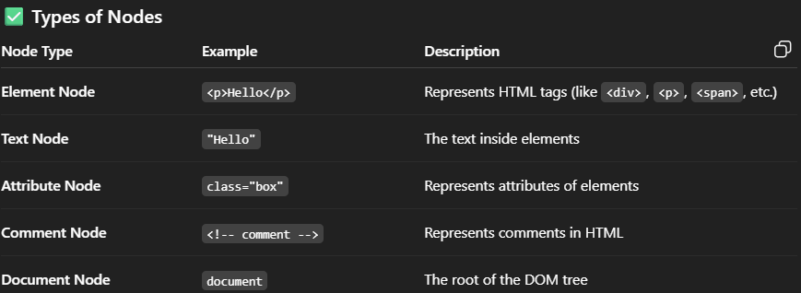
ELEMENT; Every HTML tag = an element node.
- querySelector(), getElementById()
- querySelectorAll(), getElementsByTagName()
- Nodes are the tags in html
- Elements are the attributes
- DOM selection methods
- getElementById(); select single element by unique id
- getElementsByTagName(); selects all elements with the specific given tag div, li etc
- querySelector(); selects first element matches a css selector .box, .myContainer
- querySelectorAll(); selects all elements that matches a css selector
- setAttribute, getAttribute
DOM Traversal methods
- children, descendants, parent, ancestors
- 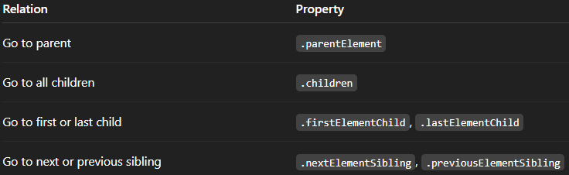
- 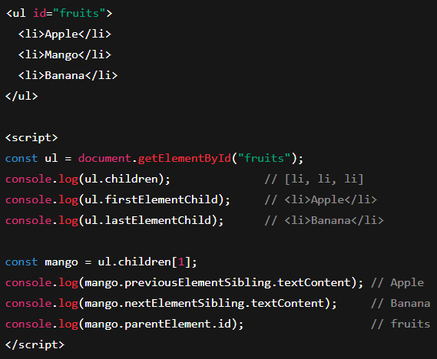

Day 06
- *{…} => css in this applies to all elements and called universal selector (*)

Day 09
- Arrays different ways:
  - Const arr =[1]
  - Const arr =[‘hi’]
  - Const arr = Array[1]
  - Const arr = Array[‘hi’]
  - Const arr = new Array[1]
  - Const arr = new Array[‘hi’]
  - Const arr = Array.of(1)
  - Const arr = Array.of(‘hi’)
  - Const arr = Array.from(‘hi’)
  - Const arr = Array.from(1)
Day 10
- Arrays
  - Stores duplicate values
  - Maintains order
  - Access by index
- Common Array Methods
Method | Description | Example
push() | Adds an element to the end | fruits.push("orange")
pop() | Removes the last element | fruits.pop()
shift() | Removes the first element | fruits.shift()
unshift() | Adds element at the start | fruits.unshift("kiwi")
indexOf() | Finds index of element | fruits.indexOf("banana")
includes() | Checks if element exists | fruits.includes("apple")
slice() | Returns part of array (no change) | fruits.slice(1, 3)
splice() | Adds/removes elements (changes array) | fruits.splice(1, 1, "grapes")
concat() | Joins arrays | arr1.concat(arr2)
join() | Converts array to string | fruits.join(", ")
reverse() | Reverses the array | fruits.reverse()
sort() | Sorts elements | fruits.sort()
filter() | Returns elements matching a condition | numbers.filter(n => n > 5)
map() | Transforms array values | numbers.map(n => n * 2)
reduce() | Reduces array to a single value | numbers.reduce((a, b) => a + b)
forEach() | Loops through array | fruits.forEach(f => console.log(f))
find() | Finds first matching element | numbers.find(n => n > 10)
some() | Checks if any element matches | numbers.some(n => n > 10)
every() | Checks if all elements match | numbers.every(n => n > 0)

- Sets
  - A Set is a collection of unique values.
  - It automatically removes duplicates and does not maintain index.
- Common Methods:
Method | Description | Example
add(value) | Add an element | set.add(5)
delete(value) | Remove element | set.delete(2)
has(value) | Check existence | set.has(3)
clear() | Remove all elements | set.clear()
size | Number of elements | set.size
- Maps
  - A Map is a collection of key–value pairs, like an object
  - keys can be any type (not just strings!)
- Common Methods:
Method | Description | Example
set(key, value) | Add or update key-value | map.set("name", "Ali")
get(key) | Get value by key | map.get("name")
has(key) | Check if key exists | map.has("name")
delete(key) | Remove entry | map.delete("age")
clear() | Remove all entries | map.clear()
size | Number of entries | map.size

